**Travel and Hospitality industry** encompasses businesses and services that cater to travelers and tourists, providing accommodations, transportation, dining, and recreational experiences. It is one of the largest global industries, significantly contributing to the world economy.

### **Key Sectors:**

1. **Accommodation:** Hotels, resorts, vacation rentals, and hostels that provide lodging for travelers.
2. **Transportation:** Airlines, railways, car rentals, cruise lines, and ride-sharing services for seamless travel.



An emerging aviation firm wants to identify potential high values customers/guests, manual process is time consuming.

Leverage data and Genai approach to help the aviation firm to collect guest/customer details through ‘Google Search’ using LLMs.

Gemini API provides access to a number of models from the Gemini model family, for Google Search grounding

* models/gemini-1.5-pro-002
* models/gemini-1.5-flash-002
* models/imagen-3.0-generate-002

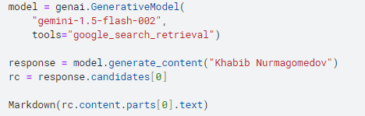

### **Response metadata**[**¶**](https://www.kaggle.com/code/markishere/day-4-google-search-grounding#Response-metadata)

When search grounding is used, the model returns extra metadata that includes links to search suggestions, supporting documents and information on how the supporting documents were used.

Each "grounding chunk" represents information retrieved from Google Search that was used in the grounded generation request.

**Guest profiles enable airlines to deliver enhanced experiences to customers.**